Class (Instance) Scope

📌 Definition:
# Source: AI Source: Provided by: [Data Path: Persons Table -> ID Column: 1, Name_En Column: Motasem Essam] -> From: [Chatgpt (GPT‑5 Mini)] on [12/9/2025]
Class (instance) scope refers to variables that are declared inside a class but outside any method, and are accessible by all methods of that class (depending on visibility).

🧠 Simple idea:
# Source: AI Source: Provided by: [Data Path: Persons Table -> ID Column: 1, Name_En Column: Motasem Essam] -> From: [Chatgpt (GPT‑5 Mini)] on [12/9/2025]
Class Scope = “Shared inside the class” 🏠

🔍 Key characteristics:
# Source: AI Source: Provided by: [Data Path: Persons Table -> ID Column: 1, Name_En Column: Motasem Essam] -> From: [Chatgpt (GPT‑5 Mini)] on [12/9/2025]
- 🧱 Declared inside a class, outside methods
- 🔄 Accessible by all methods in the class
- 👤 Each object has its own copy (instance variables)
- 🔐 Access depends on visibility (private, public, etc.)
- ⏳ Exists as long as the object exists

📌 Example (Java):
# Source: AI Source: Provided by: [Data Path: Persons Table -> ID Column: 1, Name_En Column: Motasem Essam] -> From: [Chatgpt (GPT‑5 Mini)] on [12/9/2025]
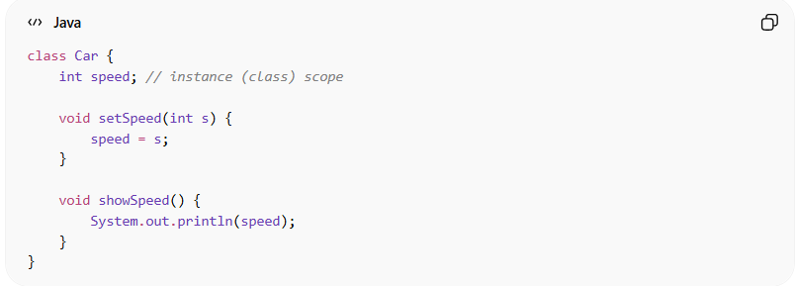
class Car {
int speed; // instance (class) scope

void setSpeed(int s) {
speed = s;
}

void showSpeed() {
System.out.println(speed);
}
}

Usage:
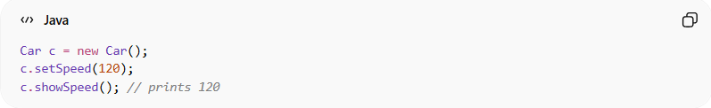
Car c = new Car();
c.setSpeed(120);
c.showSpeed(); // prints 120
👉 The variable speed:
- Is shared across methods in the class
- Belongs to the object c

🔄 Structure:
# Source: AI Source: Provided by: [Data Path: Persons Table -> ID Column: 1, Name_En Column: Motasem Essam] -> From: [Chatgpt (GPT‑5 Mini)] on [12/9/2025]
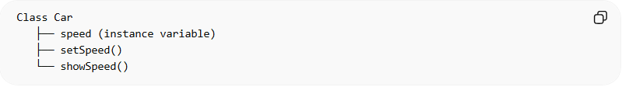
Class Car
├── speed (instance variable)
├── setSpeed()
└── showSpeed()

🎯 Why class (instance) scope is important:
# Source: AI Source: Provided by: [Data Path: Persons Table -> ID Column: 1, Name_En Column: Motasem Essam] -> From: [Chatgpt (GPT‑5 Mini)] on [12/9/2025]
- 🧩 Stores object state (data)
- 🔄 Allows methods to share data
- 🧠 Helps model real-world objects
- ⚙️ Improves code organization

🎯 Summary:
# Source: AI Source: Provided by: [Data Path: Persons Table -> ID Column: 1, Name_En Column: Motasem Essam] -> From: [Chatgpt (GPT‑5 Mini)] on [12/9/2025]
Class (instance) scope allows variables to be shared across all methods of a class while belonging to each individual object instance.

